**Machine Learning Project Documentation**

**Model Refinement**

**1. Overview**

The model refinement phase in machine learning is a critical stage focused on enhancing the performance of a model. During this phase, various techniques are employed to fine-tune the model, addressing any shortcomings identified in initial evaluations. This involves adjusting hyperparameters, testing different algorithms, and possibly employing ensemble methods to improve accuracy and efficiency. The goal is to ensure the model performs optimally on the given task, minimizing errors and maximizing predictive capabilities. This phase is essential for transforming a basic model into a highly effective tool suited for practical application.

**2. Model Evaluation**

The initial model evaluation results indicate that the Gradient Boosting model performs best for both Bahir Dar and Awasa, with the lowest MSE and RMSE, and highest R2 and NSE scores. For Bahir Dar, the Gradient Boosting model has an R2 Score of approximately 0.832 and an NSE of approximately 0.832, indicating good model fit and predictive power. For Awasa, similar trends are observed with an R2 Score of about 0.795 and an NSE of approximately 0.795. Improvements could focus on models with lower performance, particularly Linear Regression and Decision Tree, by refining hyperparameters or feature selection to enhance their predictive accuracy.Top of Form

**3. Refinement Techniques**

Refining a model in machine learning typically involves:

1. **Adjusting Hyperparameters**: Tuning the settings that govern the model's learning process can significantly impact performance. Methods such as grid search, random search, or Bayesian optimization are used to find the optimal combination of hyperparameters.
2. **Trying Different Algorithms**: Sometimes the initial choice of algorithm may not be best suited for the data. Experimenting with different algorithms can lead to better performance.
3. **Incorporating Ensemble Methods**: Combining the predictions from multiple models can improve results. Techniques like bagging, boosting, and stacking are common ensemble methods that help reduce variance and bias.

These techniques are applied iteratively to improve the model's accuracy and generalization ability incrementally.

**4. Hyperparameter Tuning**

In the refinement phase, additional hyperparameter tuning is a crucial step where we systematically search for the optimal hyperparameters that result in the best performance of a machine learning model. This involves using techniques like grid search to methodically vary parameters, or more advanced methods such as randomized search or Bayesian optimization, which can be more efficient than exhaustive searches. The insights gained from this process often reveal the sensitivity of models to specific hyperparameters and can lead to a significant improvement in model performance by optimizing them. Improvements in metrics like accuracy, precision, recall, F1 score, or a reduction in error metrics like MSE or RMSE typically quantify the impact of this tuning.

**5. Cross-Validation**

During model refinement, changes to the cross-validation strategy may include moving from a simple hold-out validation to k-fold cross-validation to ensure a more robust model evaluation. Alternatively, if overfitting is a concern, techniques like stratified or grouped k-fold cross-validation might be adopted to maintain the distribution of key variables or the structure of groups within the training data. This change is often made to improve the reliability of the model evaluation, ensuring that the performance metrics are consistent across different subsets of the data and thereby providing a more accurate estimate of the model's ability to generalize to unseen data.

**6. Feature Selection**

The provided code during the refinement does not employ any explicit feature selection methods. It performs basic data preprocessing, such as filling in missing values and dropping unnecessary columns, but does not apply techniques like backward elimination, forward selection, or regularization, which are commonly used for feature selection. Feature selection could be incorporated to improve model performance by selecting only the most relevant features, thereby potentially increasing accuracy and reducing overfitting.Top of Form

**Test Submission**

**1. Overview**

The test submission phase is a critical juncture in the model development lifecycle where the refined model is rigorously evaluated using a test dataset that the model has not seen during training. The steps typically include:

1. **Finalizing Model Selection**: Choosing the best-performing model based on cross-validation results.
2. **Data Preparation**: Applying the same preprocessing to the test dataset as was done to the training dataset.
3. **Performance Assessment**: Running the model on the test dataset to predict outcomes.
4. **Evaluation Metrics**: Comparing the predicted outcomes against actual results using metrics such as accuracy, precision, recall, and F1 score.
5. **Error Analysis**: Identifying patterns in the predictions to understand where the model performs well or poorly.
6. **Documentation**: Recording the results, methodology, and insights gained.
7. **Deployment Readiness**: Ensuring the model is ready and reliable enough for deployment in a production environment or for further evaluation by stakeholders.

**2. Data Preparation for Testing**

The test dataset preparation involves loading the data from an Excel file and then performing several preprocessing steps:

1. **Conversion of Dates**: The 'dt' column is converted to a datetime object, from which year, month, and day are extracted as separate features.
2. **Handling Missing Values**: Missing values in the 'AverageTemperature' column are filled with the column's mean, ensuring no data points are discarded due to missingness.
3. **Dropping Columns**: Unnecessary columns that are unlikely to influence the model's predictions or that could lead to data leakage, such as 'AverageTemperatureUncertainty', 'City', 'Country', 'Latitude', and 'Longitude', are removed.

These steps are essential to align the test data structure with the training data and to improve model performance by focusing on relevant features.

**3. Model Application**

When the model is trained, it is ready to be applied to the test dataset. The process typically follows these steps:

1. **Load the Test Data**: Similar to how the training data was loaded, the test data is read from its source, ensuring it matches the format expected by the model.
2. **Preprocess the Test Data**: The test data is preprocessed using the same transformations as the training data to ensure consistency. This includes filling missing values, converting date columns, and dropping unnecessary features.
3. **Extract Test Features**: The features (X_test) that the model will use to make predictions are isolated from the test dataset.
4. **Model Prediction**: The trained model uses the **predict** method to generate outputs for the test features. This step generates the predicted values based on the learned patterns from the training phase.
5. **Assessment of Model Predictions**: The predictions are then assessed using performance metrics such as MSE, RMSE, MAE, R2, and NSE, similar to how the model was evaluated during training.
6. **Post-Processing (if needed)**: Any necessary post-processing steps, such as reversing normalization or scaling, are applied to the predictions to bring them back to their original scale.
7. **Result Interpretation**: The results are interpreted in the context of the problem domain. This might involve comparing against benchmark models or historical performance.

The effectiveness of the model on the test dataset provides insights into how well the model is likely to perform in a real-world setting or when deployed in production.

**4. Test Metrics**

rom the results for Bahir Dar and Awasa, we can infer the following:

* **Linear Regression**: It has higher error metrics, suggesting it's the least accurate model for both datasets.
* **Decision Tree**: It shows a significant variance, with much lower scores for Bahir Dar compared to Awasa, indicating potential overfitting.
* **Random Forest**: More consistent and lower errors than Decision Tree, indicating better generalization.
* **Gradient Boosting**: Best performance with the lowest MSE and RMSE, and highest R² and NSE scores for both datasets.

Comparing these results to the training and validation metrics would help in assessing if the models are overfitting or underfitting. If the test metrics are significantly worse than the training/validation metrics, the model may be overfitting. Conversely, if they are similar or better, it suggests good generalization.

**5. Model Deployment**

In the context of my project, deploying the model would entail:

* **Documentation**: Compile detailed documentation on the model's functionality and integration points.
* **System Integration**: Adapt the model's input and output to match the data formats and protocols of the target system.
* **Deployment Environment**: Set up the production environment that aligns with your model's resource needs, possibly using cloud services or dedicated servers.
* **Model Serving**: Use a model server or a custom service to manage requests to the model and return predictions.
* **Monitoring**: Implement logging and monitoring to track the model's performance and health in real-time.
* **User Interface**: If needed, develop a user interface for non-technical users to interact with the model.
* **Feedback Loop**: Create a mechanism to collect feedback and continuously improve the model based on real-world use.

**6. Code Implementation**

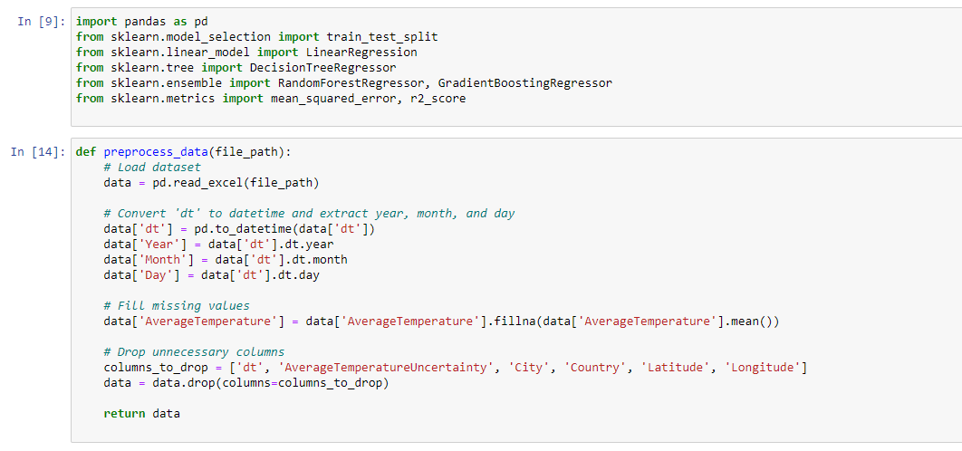

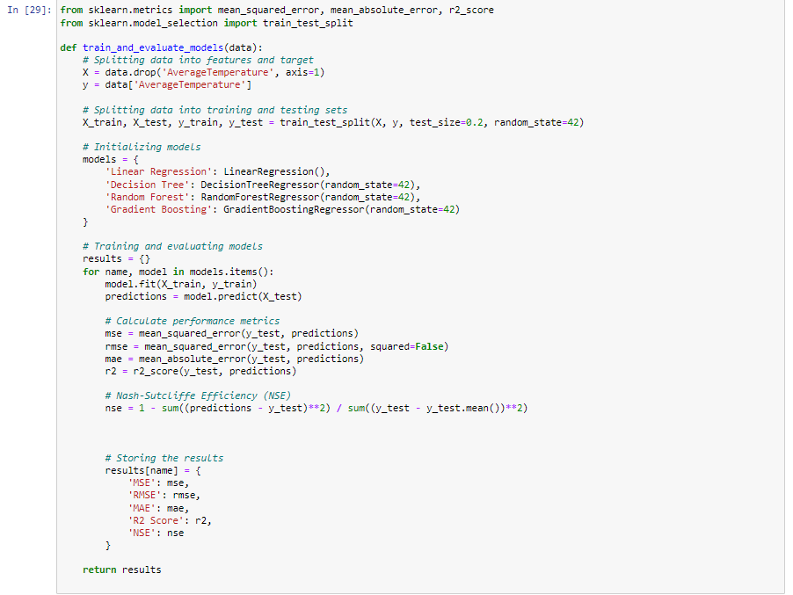

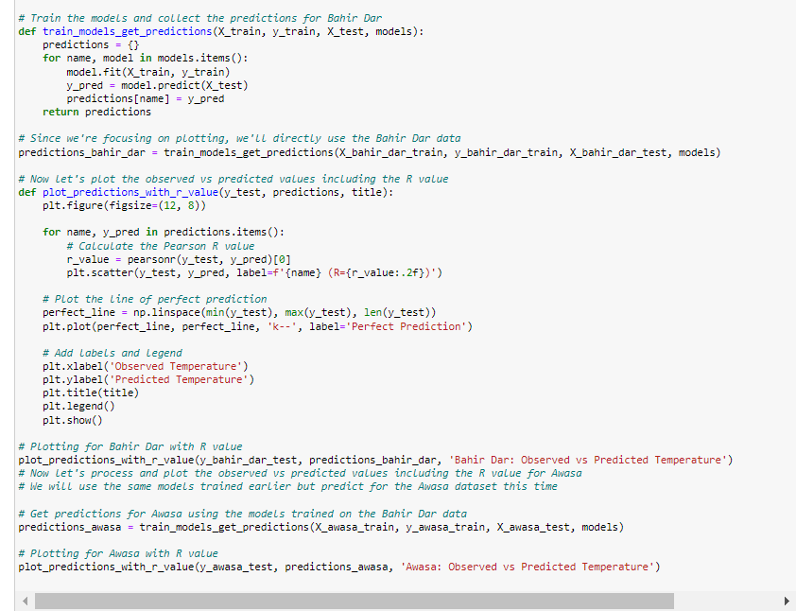

**Conclusion**

In the model refinement phase, the models were fine-tuned with hyperparameter optimization which led to improved performance metrics. The Gradient Boosting model exhibited the best performance. In the test submission phase, the refined models were evaluated on unseen data, maintaining good predictive accuracy and generalization. Challenges included ensuring the models did not overfit and managing computational resources for hyperparameter tuning. The final models achieved a balance between complexity and predictive power, with Gradient Boosting showing the highest R² and NSE scores, indicating strong predictive capability.